JCREW Lesson
8/2/20
Objective: Students will understand what it means to be salt on the earth.
Things You Will Need:
- 2 Cups
- H2O
- Salt

Intro: What images come to mind when I say the words, king, kingdom, castle, prince and princess? What kind of lives do you imagine they lead? (Receive answers.)

Girls Example: Think of your favorite princess. One of Sis. Anaya’s is Jasmin, Jasmin was blessed with soooooooo many fancy things but she also had to follow certain rules and fight for her beliefs.

Boy Example: Think about your favorite superhero. One of Sis Anaya’s is Thor. Thor was blessed with soooooooo many fancy things but he also had to follow certain rules and fight for his beliefs.

Parent Reads:

The same thing is asked of us as children of King Jesus. We have many special privileges (blessings) as children of The King. However, there are also certain rules and expectations of how we are to behave. One of the things Jesus asks of us is to be salt and light to the world.

Parents: Without your child seeing. Fill 2 cups of water in one of the cups add a good amount of salt and have your child/children try both cups. Ask what tasted different about them? Explain that one was plain and one was salty.

You Are Like Salt and Light Matthew 5:13-16 (ERV)
¹³ “You are the salt of the earth. But if the salt loses its taste, it cannot be made salty again. Salt is useless if it loses its salty taste. It will be thrown out where people will just walk on it.
¹⁴ “You are the light that shines for the world to see. You are like a city built on a hill that cannot be hidden. ¹⁵ People don’t hide a lamp under a bowl. They put it on a lampstand. Then the light shines for everyone in the house. ¹⁶ In the same way, you should be a light for other people. Live so that they will see the good things you do and praise your Father in heaven.
Parents (Read or feel to explain in your own words): During Jesus’ day salt in that part of the world was mined from rocks underground. It was mixed with clay and sand. Over time—due to exposure to rain and sun—the salt near the surface of the rock lost its saltiness, making it useless. As a result, it was tossed out and walked on. However, the salt that was closest to the inside of the rock stayed salty!
Today we mainly use salt to flavor foods. However, in Jesus’ day, salt was used to keep foods from rotting. Today we have refrigerators to keep foods fresh. So maybe if Jesus were speaking to us today he might say, “You are the refrigerators of the earth!”
Question 1: Knowing these two things about salt: being connected to the rock and keeping us from rotting, what do you think Jesus wants his children to know? Why do you think He says we are the salt of the earth?
Answer: Jesus wants us to understand that, as we remain connected to him—the Rock—we stay salty. When we move further away from Him, we lose our saltiness! When you have Jesus living in you through the power of the Holy Ghost & His word. He keeps you from spiritually rotting. As a result, Christians keep the rest of the world from rotting too!

Activity 1 Match the picture (letter) with the correct phrase (number).

3. Far from Jesus (The Rock)

1.“The Rock”
Jesus

2. Close to Jesus (The Rock)

A

B
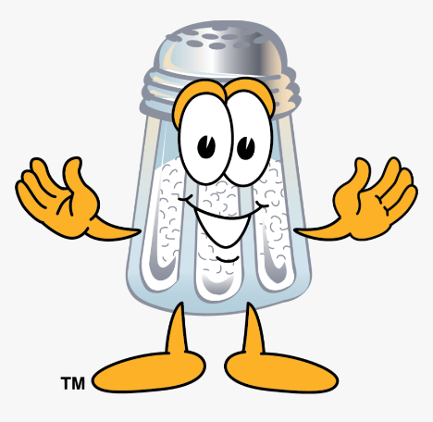
C
Just as the salty water was noticeably different, Christians should be uniquely different from other people! If we’re not, what does Jesus say will happen? (If salt loses its saltiness, it is good for nothing, throw it out!)
Question 2: How can we as Christians keep the world from rotting?
Answer: Our lives should reflect a noticeable difference in our speech, our behavior, the way we treat others, our plans and goals in life, the things we value, the way we spend our time, money, resources, talents, etc. We do these good things to give God ALL the credit, the honor and the glory!
Pray Out as Family
Reminders
Weekly Challenge (You Pick)
- Make a dance to Risen or Say So by Israel Houghton
- Make a song about the kingdom of God or being the salt of the earth or sing an already written song.
- Make a craft about being a part of Gods Kingdom or being salt on the earth (you can find links below )

https://www.youtube.com/watch?v=-f1DR5uJiR4- Make a crown tutorial
https://whereimaginationgrows.com/easy-crown-craft-kids/ Make a crown tutorial
***Don’t forget to post on the FB Remnant Page***

Scripture of the Month
Matthew 6:33 (KJV)
³³ But seek ye first the Kingdom of God and His righteousness, and all these things shall be added unto you.

