God’s Call to Diligence
Watch over your heart with all diligence, For from it flow the springs of life.
Proverbs 4:23

Today let’s look at the word Diligence again. Diligence is to give “intense or strong effort” toward something.

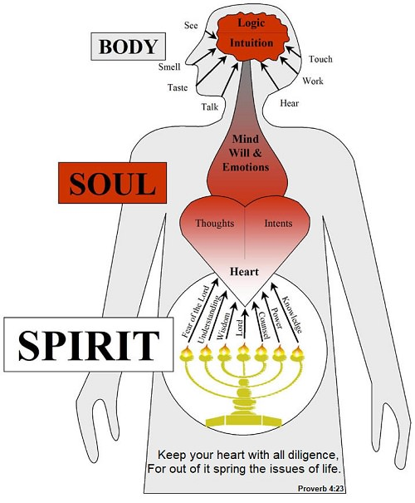

In The Bible we find instructions to live with diligence toward God. God wants our diligence to guard our heart because guarding or lack of guarding our heart can lead us to wise or unwise choices. Sometimes giving diligence all the time might not be as easy.
Can you think of moments that your diligence to obey God or your parents has been affected by how you feel?

Why would your feelings change your obedience?
It is because heart holds your thoughts and intents, but what guards your heart is your feelings and your personal will.

This is why The Bible tells us to guard our hearts. When we guard our hearts, we allow God to have first choice to influence or shape our thoughts and intents.

A Closer Look at Jacob, a Man of Diligence

Genesis 31:40-41
This was my situation: The heat consumed me in the daytime and the cold at night, and sleep fled from my eyes. ⁴¹ It was like this for the twenty years I was in your household. I worked for you fourteen years for your two daughters and six years for your flocks, and you changed my wages ten times.

Many times, we think of Jacob as the one man that loved one wife more than the other, but here we are able to see the character of Jacob in a new light. He served His father-in-law when he did not want to do it, he listened and obeyed because of the diligence God placed in him.

Jacob is a great example of a man who learned how to
- Guard his heart when challenged by life
- Allow God to bless him because of his strong effort (diligence) to do what was right

When Jacob guarded his heart, and did the right thing, God blessed him and increased the things he had (Genesis 30:29-30)

Can you trust God to teach you to be diligent?
Memory verse:
Colossians 3:17- And whatever you do, in word or deed, do everything in the name of the Lord Jesus, giving thanks to God the Father through him. (English standard version
There are things that we can do to show our diligence to God.

- Remember what God has shown you
- Be a good keeper of what you are given
- Keep adding to your faith

Weekly Challenge: Put God first
If you acknowledge that you need God’s help each day to guard your heart, then the first thing you should do in the morning is to spend time with Him. I challenge you to listen to our worship song (Wordy Birds-Lifeway Worship) once a day with your parents. From it, you will find the memory verse Colossians 3:17!

